**SVKM’s NMIMS**

**Mukesh Patel School of Technology Management & Engineering**

**Computer Engineering Department**

Program: B.Tech Integrated Sem V

**Course: Basic Data Structures**

**2024-2025**

**Experiment No.02**

PART A

(PART A : TO BE REFFERED BY STUDENTS)

**A.1 Aim:**

Introduction to Data Structures and implementation of Arrays

**A.2 Prerequisite:**

1. Knowledge of different types of data structures.

2. Fundamental concepts of C\C++.

**A.3 Outcome:**

**After successful completion of this experiment students will be able to**

1. Identify the need of appropriate selection of data structure
2. Explore the effect of appropriate data structure selection.
3. Differentiate types of data structure based on their organization of data.
4. Enlist the applications of different data structure.
5. Implement arrays for the given problem

**A.4 Theory:**

### A.4.1. Inserting a new element in an array

A new element can be inserted at any position of an array if there is enough memory space allocated to accommodate the new element. Some of the elements should be shifted forward to keep the order of the elements. Suppose we want to add an element 93 at the 3rd position in the following array.

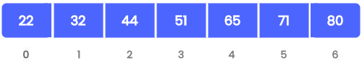

Initial array

After inserting all elements comes after 32 must be moved to the next location to accommodate the new element and to keep the order of the elements as follows.

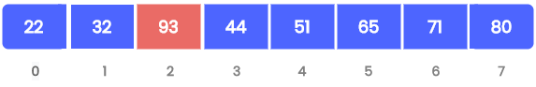

Array after inserting a new element

### Deleting an element from an array

Suppose we want to delete element 44 at the 3rd position in the following array.

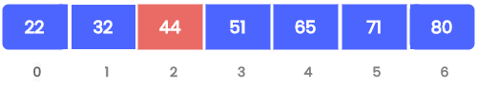

Initial array

After deletion, all elements coming after 44 must be moved to the previous location to fill the free space and to keep the order of the elements as follows.

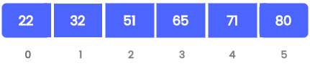

Array after deleting an element

#### Algorithm

* Find the position of the element to be deleted in the array.
* If the element is found,  
  Shift all elements after the position of the element by 1 position.  
  Decrement array size by 1.
* If the element is not found: Print “Element Not Found”

**A.5 Procedure/Algorithm:**

**A.5.1:**

**TASK 1:**

Write a C++ program of array to perform following **(1D Array)**

1. Insertion operation in an arrays.

a) Insertion at the end of array

b) Insertion at specific position in an array

1. Deletion operation in an array.

A) Deletion from the end of array

B) Deletion from particular position in array

C) Deleting a particular element in an array

**Task 2:**

**Temperature Monitoring**

You are working on a weather monitoring system that records the daily temperatures of a city over a month. You need to perform various operations such as finding the highest and lowest temperatures, calculating the average temperature, and identifying days when the temperature was above a certain threshold.

**Questions**:

1. **Data Storage**:
   * How would you use a 1D array to store the daily temperatures?
   * Why is a 1D array appropriate for this task?
2. **Implementation**:
   * Write a function to find the highest and lowest temperatures in the month.
   * Write a function to calculate the average temperature for the month.
   * Write a function to count the number of days the temperature was above a given threshold.
3. **Edge Cases**:
   * How would your functions handle an empty array (e.g., no temperature data available)?
   * What would be the output if all temperatures are the same?

**********************

PART B

(PART B : TO BE COMPLETED BY STUDENTS)

***(Students must submit the soft copy as per following segments within two hours of the practical. The soft copy must be uploaded on the Blackboard or emailed to the concerned lab in charge faculties at the end of the practical in case the there is no Black board access available)***

|  |  |
| --- | --- |
| Roll No. C146 | Name: Manan Gandhi |
| Class : D | Batch : D1 |
| Date of Experiment: 2/7/24 | Date of Submission |
| Grade : | Time of Submission: |
| Date of Grading: |  |

**B.1 Software Code written by student:**

***(Paste your code completed during the 2 hours of practical in the lab here)***

**Task 1:**

/*

Insertion at specific position in an array

*/

#include <iostream>

using namespace std;

int main()

{

int arr[] = {1};

int n = 0, index = 0, value = 0;

cout << "Enter length: ";

cin >> n;

cout << "Enter elements of array: " << endl;

for (int i = 0; i < n; i++)

{

cout << i + 1 << ": ";

cin >> arr[i];

}

cout << "Enter index to insert: ";

cin >> index;

cout << "Enter value to insert: ";

cin >> value;

for (int i = n; i >= index; i--)

{

arr[i] = arr[i - 1];

}

arr[index - 1] = value;

cout << "The array is: " << endl;

for (int i = 0; i < n + 1; i++)

{

cout << i + 1 << ": " << arr[i] << endl;

}

}

**Task 2:**

/*

Insertion at end of array

*/

#include <iostream>

using namespace std;

int main()

{

int arr[] = {1};

int n = 0, value = 0;

cout << "Enter length: ";

cin >> n;

cout << "Enter elements of array: " << endl;

for (int i = 0; i < n; i++)

{

cout << i + 1 << ": ";

cin >> arr[i];

}

cout << "Enter value to insert: ";

cin >> value;

arr[n] = value;

cout << "The array is: " << endl;

for (int i = 0; i < n + 1; i++)

{

cout << i + 1 << ": " << arr[i] << endl;

}

}

**Task 3:**

/*

Deletion from the end of array

*/

#include <iostream>

using namespace std;

int main()

{

int n;

cout << "Enter the size of the array: ";

cin >> n;

int arr[n];

cout << "Enter the elements of the array: ";

for (int i = 0; i < n; i++)

{

cin >> arr[i];

}

n--;

cout << "Array after deletion: ";

for (int i = 0; i < n; i++)

{

cout << arr[i] << " ";

}

cout << endl;

return 0;

}

**Task 4:**

/*

Deletion from particular position in array

*/

#include <iostream>

using namespace std;

int main()

{

int n;

cout << "Enter the size of the array: ";

cin >> n;

int arr[n];

cout << "Enter the elements of the array: ";

for (int i = 0; i < n; i++)

{

cin >> arr[i];

}

int pos;

cout << "Enter the position of the element to be deleted: ";

cin >> pos;

for (int i = pos; i < n - 1; i++)

{

arr[i] = arr[i + 1];

}

n--;

cout << "Array after deletion: ";

for (int i = 0; i < n; i++)

{

cout << arr[i] << " ";

}

cout << endl;

return 0;

}

**Task 5:**

/*

Deleting a particular element in an array

*/

#include <iostream>

using namespace std;

int main()

{

int n;

cout << "Enter the size of the array: ";

cin >> n;

int arr[n];

cout << "Enter the elements of the array: ";

for (int i = 0; i < n; i++)

{

cin >> arr[i];

}

int element;

cout << "Enter the element to be deleted: ";

cin >> element;

int found = 0;

for (int i = 0; i < n; i++)

{

if (arr[i] == element)

{

found = 1;

for (int j = i; j < n - 1; j++)

{

arr[j] = arr[j + 1];

}

n--;

break;

}

}

if (found == 0)

{

cout << "Element not found in the array" << endl;

}

else

{

cout << "Array after deletion: ";

for (int i = 0; i < n; i++)

{

cout << arr[i] << " ";

}

cout << endl;

}

return 0;

}

**B.2 Input and Output:**

***(Paste your program input and output in following format, If there is error then paste the specific error in the output part. In case of error with due permission of the faculty extension can be given to submit the error free code with output in due course of time. Students will be graded accordingly.)***

**Task 1:**

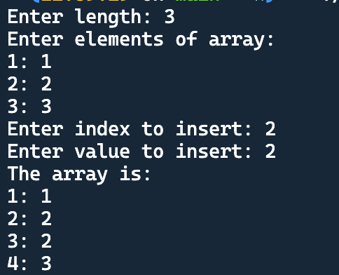

**Task 2:**

**Task 3:**

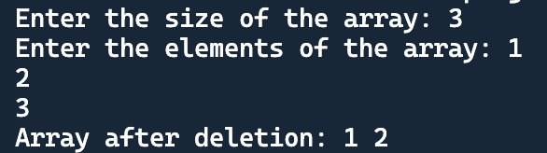

**Task 4:**

**Task 5:**

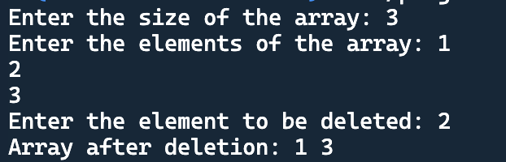

**B.3 Conclusion:**

*(****Students must write the conclusion as per the attainment of individual outcome listed above and learning/observation noted in section B.3)***

**B.4 Question of Curiosity**

***(To be answered by student based on the practical performed and learning/observations)***

Q1. How an arrays can be declared in the form of an ADT?

************************